Narendra Verma
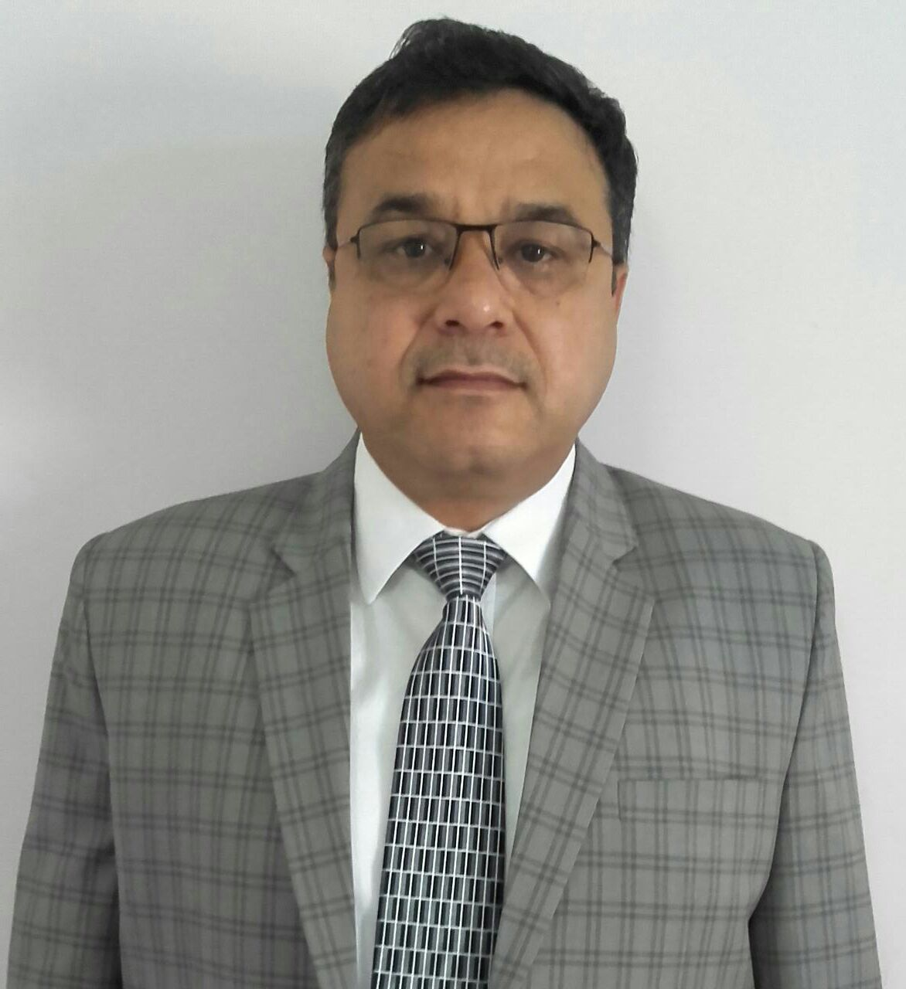
C-2 / 4 8 C, M.I.G. Flats, Lawrence Road, Delhi – 110035
Contact Number – 9650777050
Email – Narendravarma69@yahoo.com

SYNOPSIS

- A result driven professional with experience in Sales & Marketing across varied industries.
- Experience comes from various sectors viz. FMCG / Consumer durable / Government / Industrial / Construction.
- Worked in major PAN India regions with focus on continuous growth.
- Ability to formulate and implement tactical initiatives.
- Proven ability in forecasting plan and executing them in given time frame.
- Experience in successful launch of products and strengthening existing products.
- Outstanding success in building & maintaining relationships with key clients.
- A skilled communicator with presentation skills in leading cross-functional teams.
- Ability to get leadership position to exceed stakeholders’ expectation – achieving through financial parameters.

- Areas of Expertise

Business through core values Strategic Planning Foster an energized culture
Decision based on data analysis Customer Relationship Management Team Building & Leadership
Product launch Business Negotiations P & L

CORE COMPETENCIES

- Steering operations with a view to achieve organizational objectives and ensure profitability.

- Planning activities & preparing strategies to accomplish annual plan.

- Reviewing & interpreting the competition & market information to fine tune counter actions.

- Interfacing with customers for understanding their requirements & recommending new products in accordance with pricing, customer needs, and requirements.

- Making decision based on reports analysis.

- Performing under demanding work environments, meeting deadlines.

- Imparting continuous on job training to the workforce for enhancing their productivity.

- Interacting with Builders / Customers / Architects to promote business.

- Organizing promotional activities like independent presentations, seminars, direct mailers, exhibitions & trade shows and live demonstrations.

CAREER CONTOUR

June 2011 – July 2021
Otis Elevator Company India Ltd.
Designation – Senior Manager Sales – North
Business Area – J&K, Himachal Pradesh, Punjab, Chandigarh, Haryana and Rajasthan.

Otis Elevator Company is the world’s leading manufacturer, installer and maintainer of elevators, escalators and moving walkways—a constant, reliable name for more than 160 years

Role

- Setting measurable strategic goals with time deadline.
- Communicating on the behalf of company with customers (internal and external)
- Focussing on long and short terms goals.
- Lead regional team and evaluating the work of team.
- Maintaining awareness of competitive market landscape and expansion opportunities.
- Doing business with social responsibility.
- Assessing company risk, measuring them and minimise them.
- Generating profitable business based on core values.
- Developing and implementing effective sales strategy.
- Monitor and analyse performance metrics and suggest improvements.
- Negotiate and close key customers.
- Prepare annual plan.
- Recruitment and training of team members.

Achievements

- Generating business based on core values integrity, ethics, innovation, quality & commitment to customers.
- Contributing & Managing North India UPC business worth Rs. 127 Crores / Year covering geographical spread of J&K, Punjab, Chandigarh, Haryana, Himachal Pradesh, Rajasthan ,UP & Uttarakhand . (7 states & 1 UT)
- Registering 100 % growth from 2011 to 2021
- Improving share of segment.
- Promoting green technologies for sustaining environment.
- Launching and establishing new products & strengthening present one.
- Imparting training and fostering culture of learning.
- Offering solutions based on applications.
- Actions based on data using CRM.
- Conducting techno commercial presentations to key customers, government houses.
- Winning key accounts with strategy…
- Quality actions – Improved terms of payments for better cash flow. Quality contract management.
- Coverage - developing 2 /3 tier cities.
- Power of Attorney holders for company ( worth Rs. 50 lacs )
- Wining tenders from Government departments – VIZ CPWD – PWD – AAI – Railways – UPNNL- PGI – IIT – MES -JKMED – medical colleges etc.

July 09 to Oct 2010
Palfinger Cranes India Pvt Ltd.
Designation -Product & Sales Manager
Business Area - (North, Central & East India)

Leading manufacturer & marketers of truck mounted cranes with business turnover of Rs. 5500 crores. The Company is into various types of cranes for Infrastructure Projects (Roads, Flyovers, Bridges, R.O.B., Tunnels, etc.), metro, real estate, electricity, steel, pipeline refinery & PSU, industrial, solid waste management, etc.
Job Role

- Overseeing the functions entire gamut of business operations for Palfinger Truck Mounted Cranes/Hook Loaders / Special cranes.
- Directing the sales teams in attaining the performance targets by training for better business performance using CRM.
- Acquiring customers; understanding need & recommending solutions for optimum results by drawing conclusions.
- Training the customers on the safe and correct use of the products and attending techno-commercial discussions.
- Preparing, submitting and following-up prequalification application to PSU, Government, Defence and Railways.
- Maintaining the high-level Government and industries contacts with decision makers.
- Instrumental in developing marketing strategy formulation for building brands.

Key Highlights

- Successfully introduced & established truck mounted cranes, hook loaders.
- Won business based on applications by offering solution.
- Initiated rental concept for speedy acceptance of product.
- Initiated live demonstration to demonstrate product benefits.
- Organised promotional activities like independent presentations, seminars, direct mailers, exhibitions & trade shows.

Jun ‘06 – Jul ’09
Chowgule and Company Pvt. Ltd.,
Designation – Sales Manager
Business Area - Sales Manager – Central & East India;

Rs. 3500 Crore Groups Company is into truck / tractor mounted crane JV with Unic Furukawa, Japan.

Job Role
- Introducing as well as establishing the truck / tractor mounted business for Central and East India.
- Initiating marketing policies for business development; spotting out new customers and finalizing sales.
- Overseeing the complete key account management and building strong relationship with trade network.
- Spotting out new business opportunities and new segments to enhance business base.
- Tracking various upcoming projects.

Key Highlights
- Instrumental techno-commercial presentations for customers based on applications concluding business.
- Effectively liaised with the Government houses for product specifications & total tender activities.
- Fostered business through promotional activities (fairs, roadshows, seminars, etc.)
- Ascertained smooth business transactions and made the regions as consistent revenue generating market.

July ’01 – Jun ’06
Bell Granito Ceramica Ltd.
Designation – Sales Manager
Business Area -North & East India as Sales Manager
Company is into manufacturing & marketing of floor vitrified tiles in construction industry.

Job Role
- Leading a team; handling the sales and growth throughout North & East India and developing it into a profitable center.
- Creating an appropriate business strategy for increasing market share of the product.
- Overseeing the independent execution and completion of projects for Government, PSU and Corporate; creating as well as developing the marketing plan for the projects.

Key Highlights

- Instrumental in interacting as well as coordinating with the consultants, architects, builders, interior designers and customers for technical matters and approvals.
- Handled the project tracking in infrastructure, etc. and managed the outstanding collection.
- Oversaw business through network of customers, dealers and opinion leaders through follow-ups, techno-commercial skills and negotiations.

Dec ‘96 – July’01
DCW Home Products Ltd.
Designation - Area Sales Manager
Business Area – Delhi NCR.
This is a FMCG company, manufacturing Captain Cook Salt, Atta, and Spices.

Job Role
- Handling the sale of company products in Delhi; launching and establishing the Captain products through large network and volumes.
- Spearheading a team of 12 Sales Professionals & 22 distributors towards performance targets.
- Formulating the product plan and pricing strategies; handling the speedy distribution and promotional activities.
- Implementing the corporate policies; handling the supply chain logistics including commission, discounts/ credit terms to distributors/ dealers pricing & margins.

Key Highlights

- Instrumental in appointing financially sound consignee agents, distributors, dealers and market coverage; providing inputs to the team regarding sales forecasting.
- Adeptly prepared & obtained approval for annual expense budgets related to sales, marketing & supply chain.

Feb ‘91 – Dec ‘96
Godfrey Phillips India Ltd.
Designation - Sales supervisor (North Region)
Business Area - UP

The company is the market leader in Cigarette Industry– a subsidiary of Phillip Morris (Marlboro brand).

Job Role

- Creating the sales and marketing strategy for effective penetration as well as maximum market share.
- Formulating business plans; establishing sales with large wholesale distributors, dealers, retailers and customers.
- Managing the financial and administrative functions.
- Implementation of sales strategies.

Key Highlights

- Ensured full time availability of brands by improving frequency and penetration.
- Successfully launched products; achieved both qualitative and quantitative objectives within the time frame.
- Won abroad visits to Hong Kong, Bangkok, Philipines, Pattaya, Kathmandu, Shimla, etc.
- Worked towards achieving the optimum staff performance by improving overall actual presence.
- Vital role in reorienting dispatch operation to ensure full time availability of all the products at all the outlets.
- Organized the trade and promotional activities
- Evaluated the chief challenges and practical solutions to simplify system.

ACADEMIA

- B.Sc. (Electronics) from Delhi University, New Delhi in 1989.
- Import/ Export Certificate Course from UP Export Corporation Ltd. in 1997.

IT FORTE

Operating System : Windows
Applications : MS Office, Internet, Customer Relationship Management package of Microsoft Dynamics CRM 3.0

PERSONAL DOSSIER
Date of Birth : 10th January 1969
Valid Passport : Available

